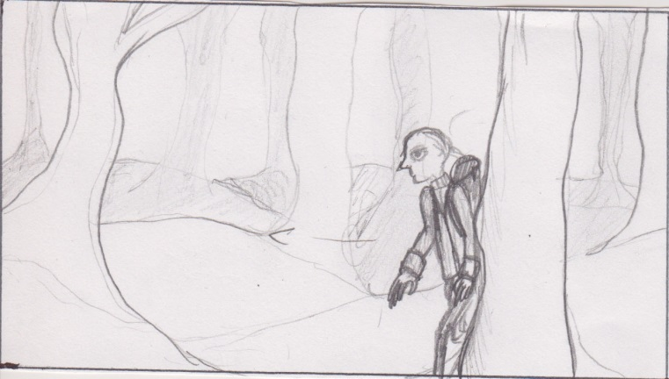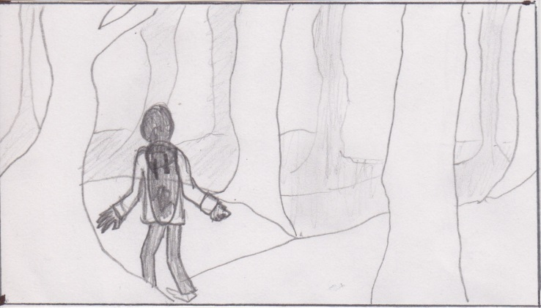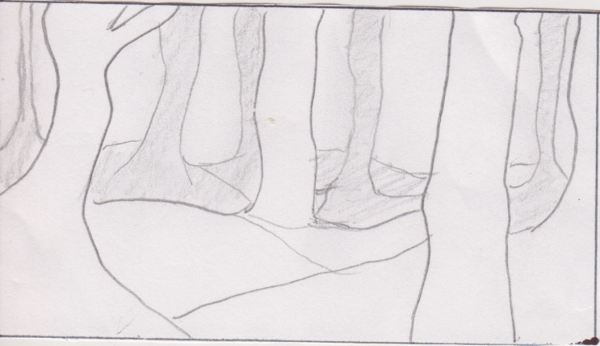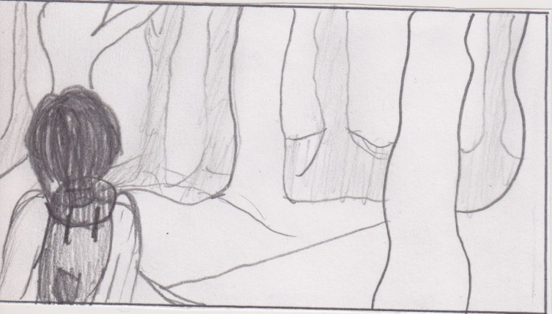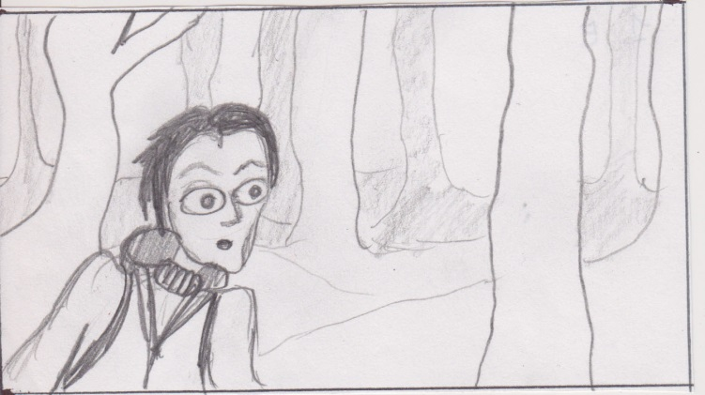

**Shot 1 – 217 frames.**

Split in 2: 1a = 98 frames. Medium/wide, small puppet in flat trees background/composited foreground

1b = 58 frames. Medium/close, large scale puppet, green screen, composited against same background + foreground as shot 1a.

Man is walking from right to left while turning body around, moving head quickly, arms up a bit with opened hands (anxious), scared of sudden sound, moves out of frame.

*title*

Man comes back in frame in foreground (now medium/close) from the left, walking backwards slowly, then, a sound, suddenly turns around, watching frightened with wide open eyes.

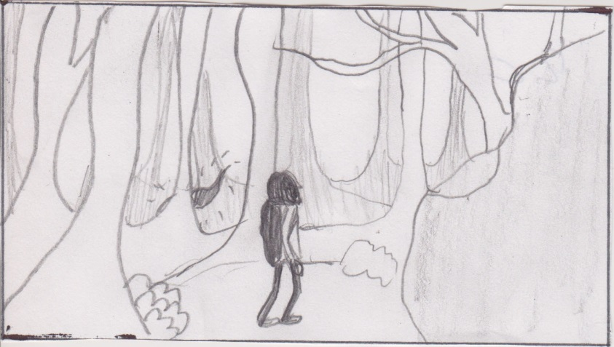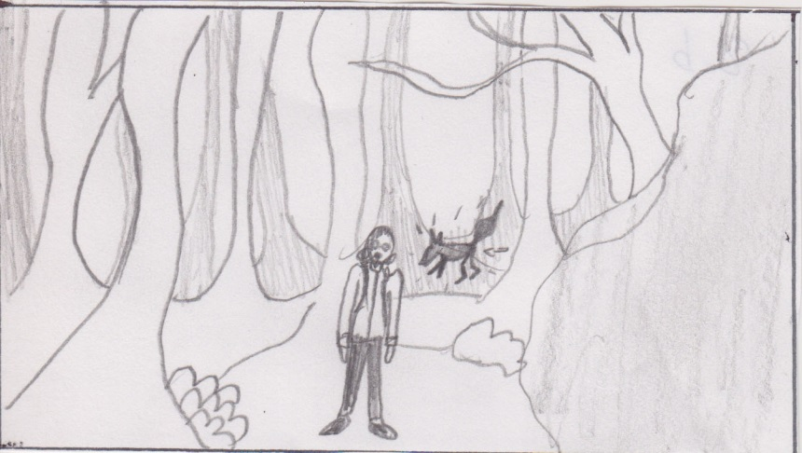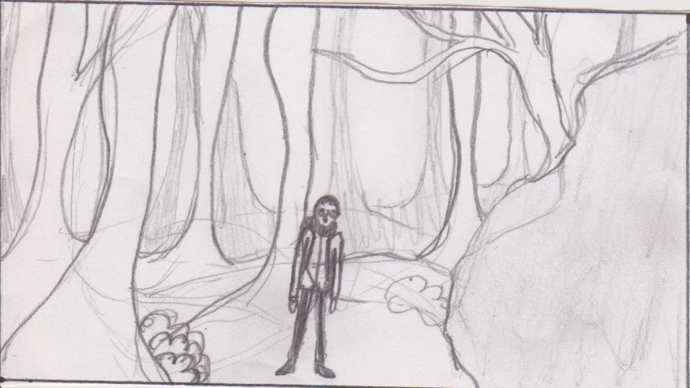

**Shot 2 – 122 frames.**

Shot as 2 separate shots:: Shot 2a = 122 frames. Wide shot, small puppet, main set

Shot 2b = 65 frames, wide/total, fox puppet, greenscreen

Timing has to be matched precisely on dope sheets! (man’s response to fox)

Man stands in the middle of the shot, just been frightened by a sound, makes a quick moveto the left, then a sound in the back, the fox walks across in the background rapidly, man turns around, tail disappears at the side, the man missed it.

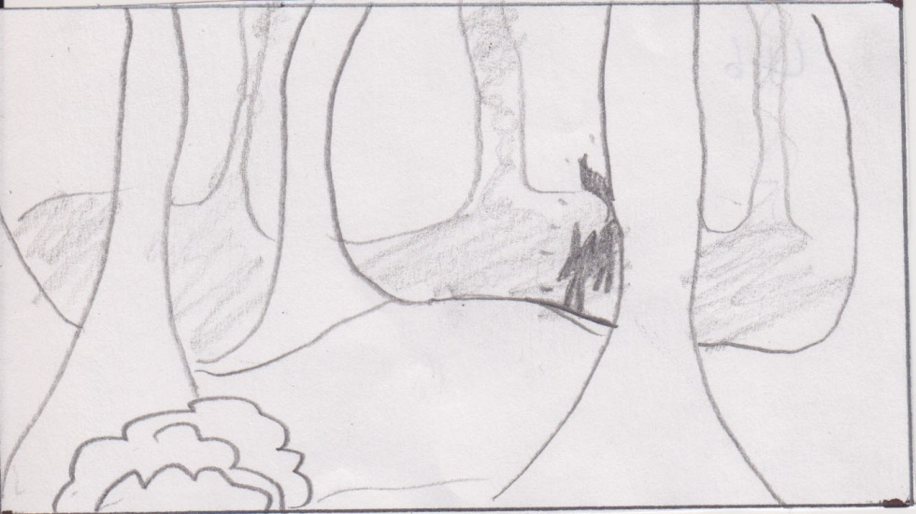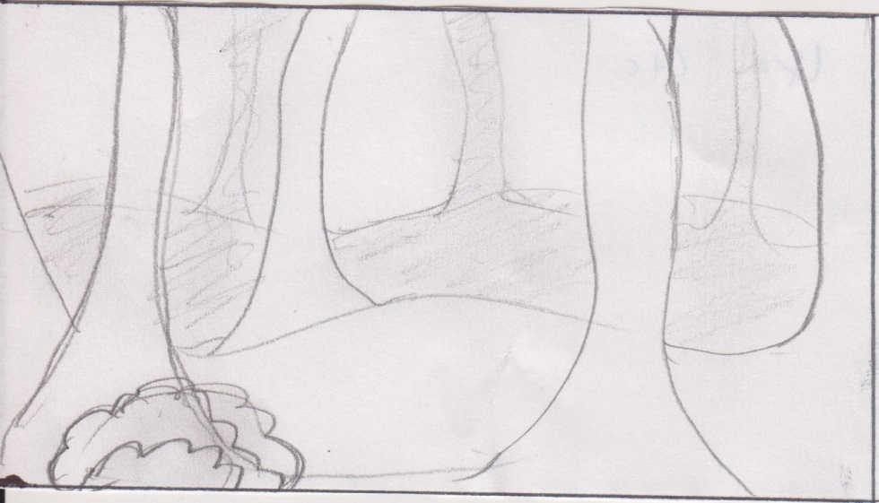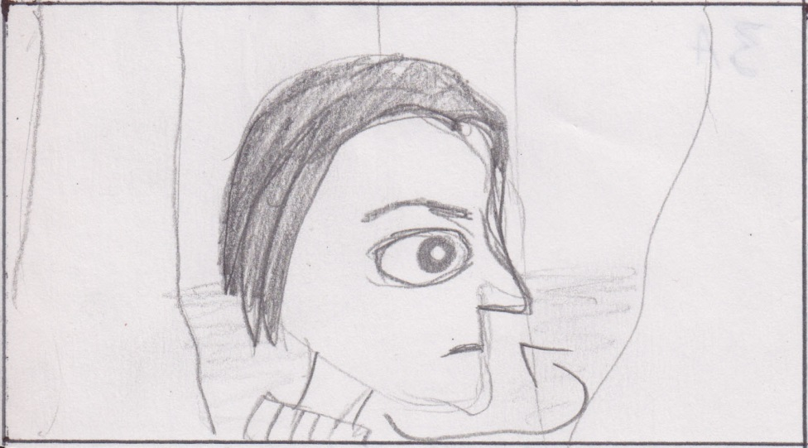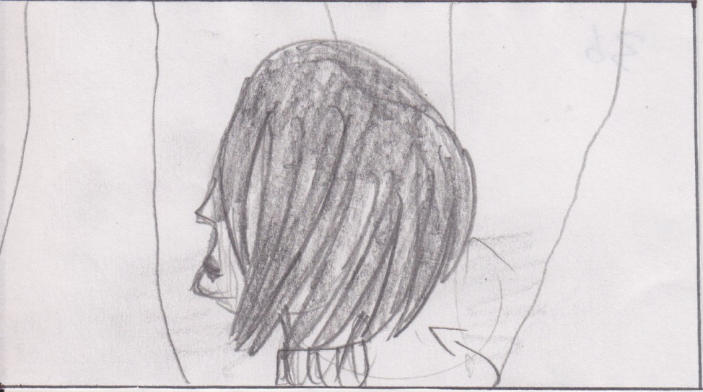

**Shot 4 – 50 frames.**

Total, fox, green screen, composited into main set between foreground & background.

Fox appears from behind hill/tree and disappears again behind another one.

**Shot 3 – 43 frames.**

Close up, large puppet, green screen, composited background

Man hears sound at the left, turns around to left.

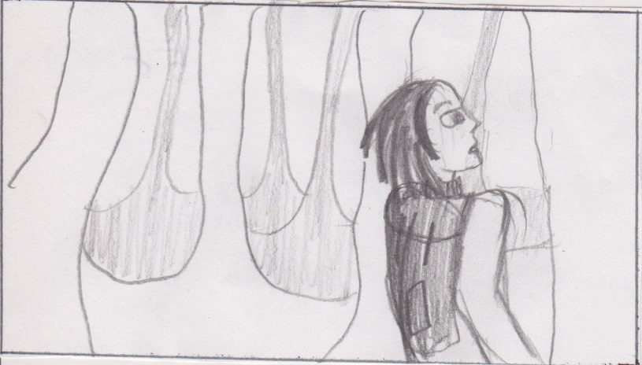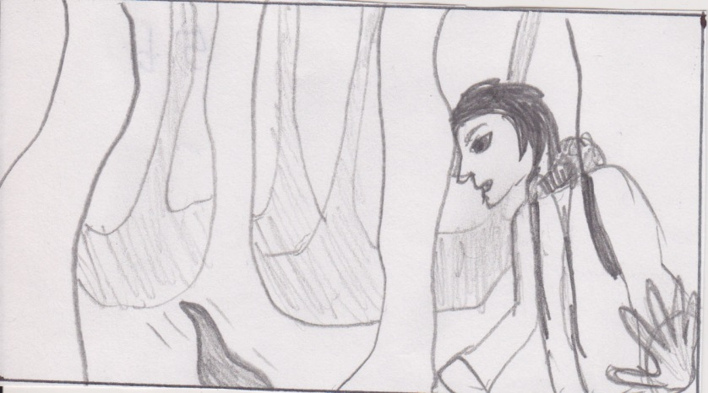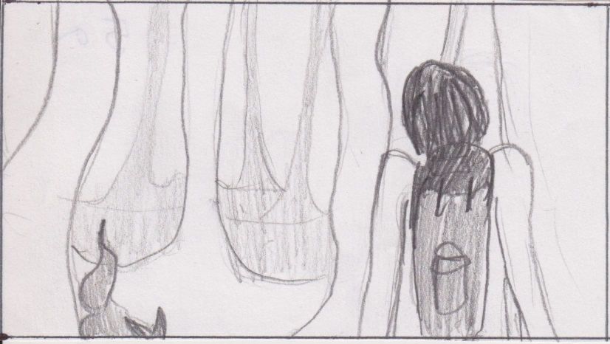

**Shot 5 – 54 frames.**

Medium, man and fox, green screen, composited in front of main set background.

Fox half in shot walks around man, man responds, looks downwards, turns around, following the fox.

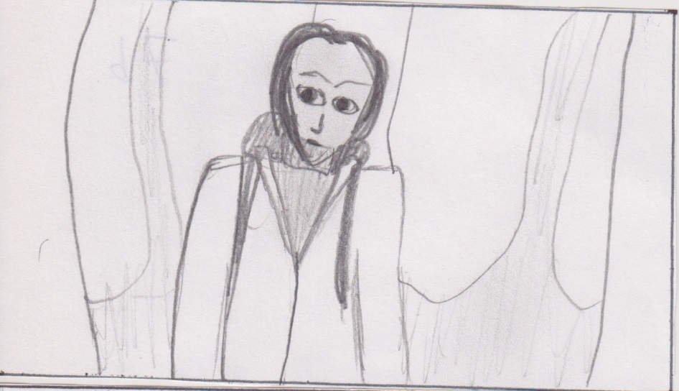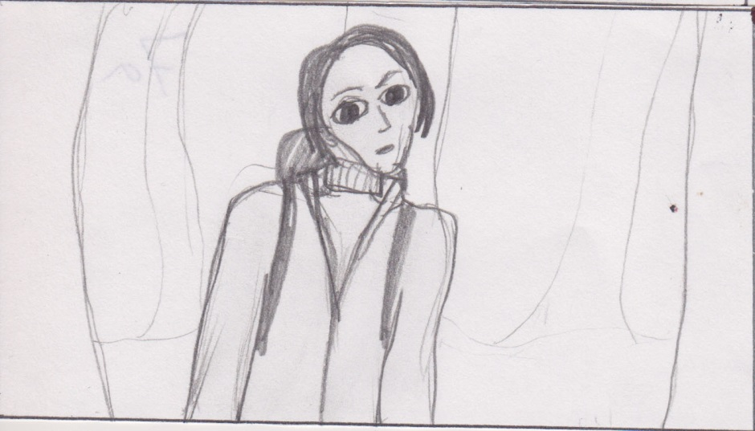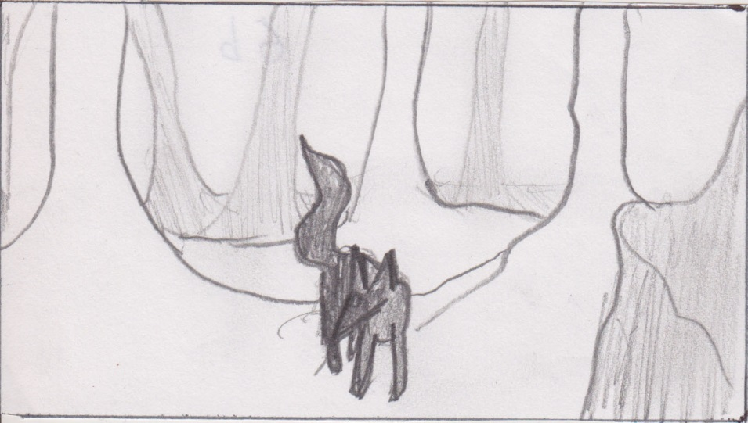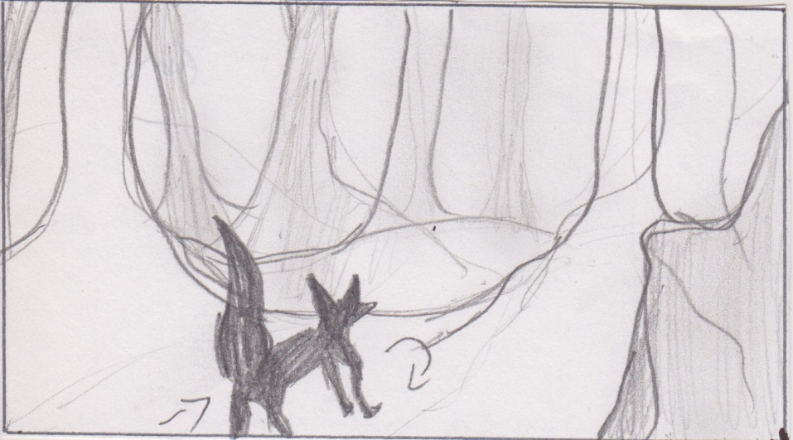

**Shot 7 – 77 frames.**

medium, man large version, green screen, composited background (flat + separate trees).

Man looks down at fox, follows him from right to left with eyes/head.

**Shot 6 – 60 frames.**

medium, fox, main set

fox walks from away from camera, then stops and turns around, looking back at the man.

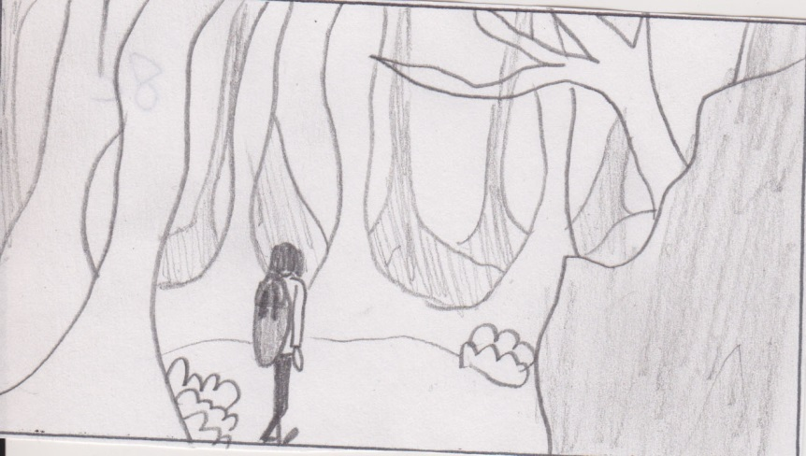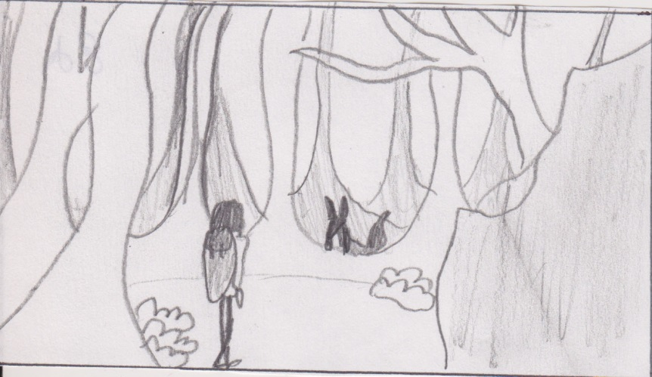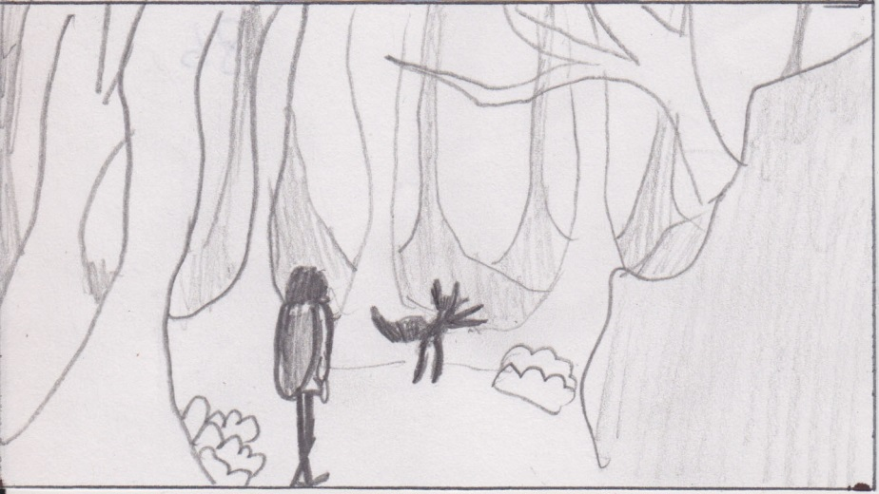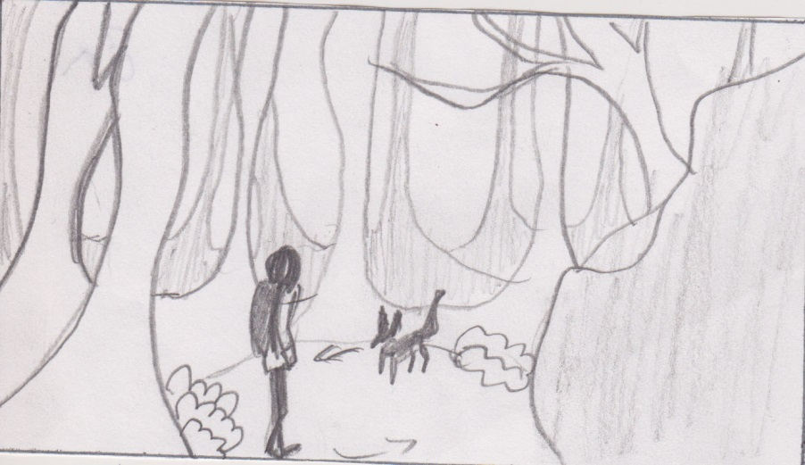

**Shot 8 – 177 frames.**

Wide shot, man small version & fox, main set.

Man and fox slowly circle around each other (only first 2-3 steps), then fox stops and runs away, man stands still, one step in direction of where fox went. Fox comes back around corner, looks at man, man looks up.

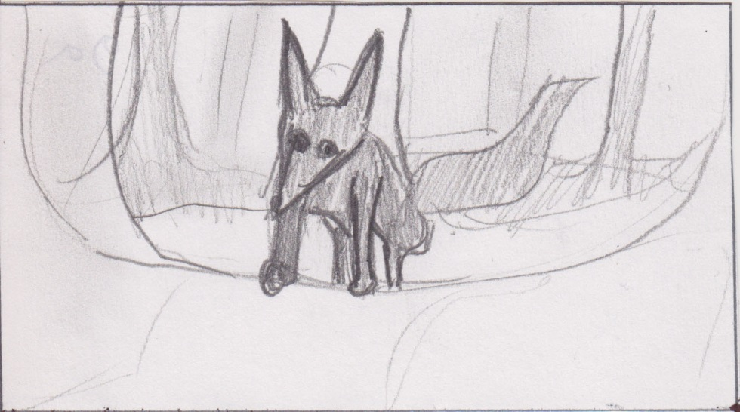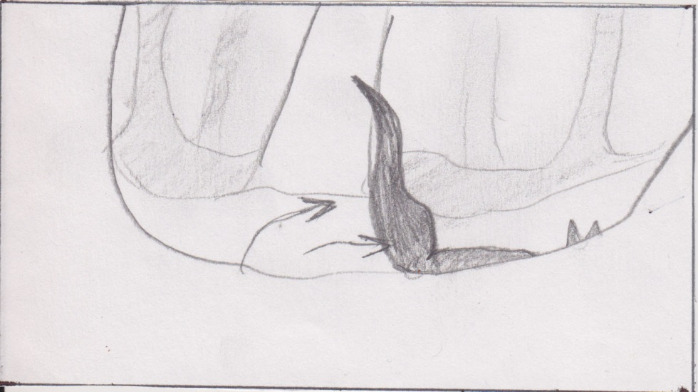

**Shot 9 – 70 frames.**

Medium/close up, fox, main set.

Fox stares at man, slightly moving ears and tail, then runs off.

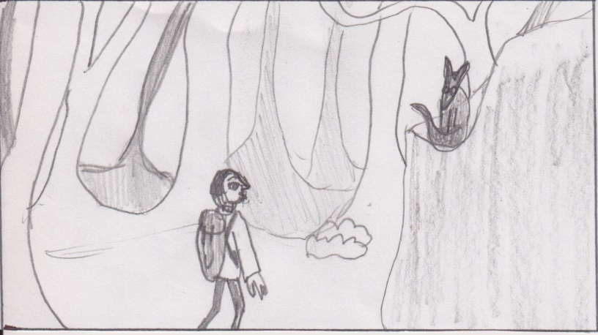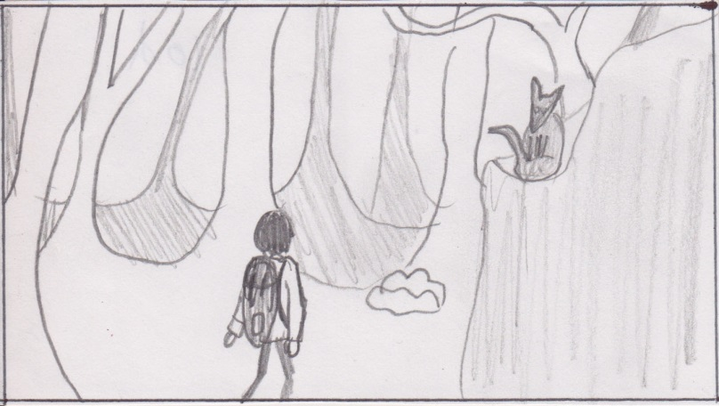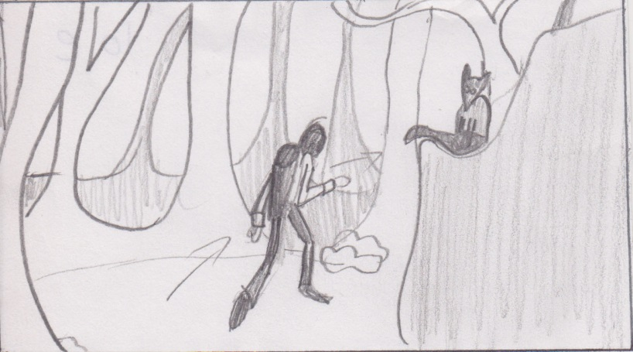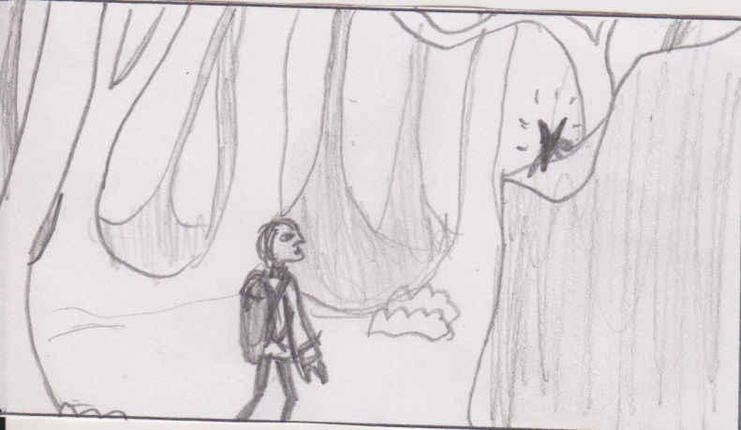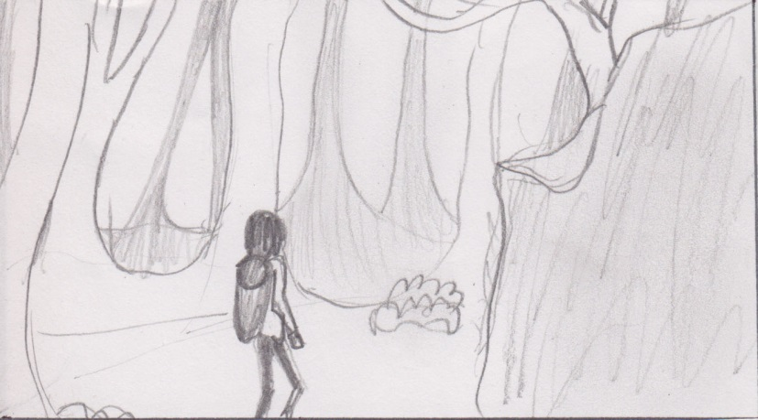

**Shot 10 – 205 frames.**

Wide shot, man small version & fox, main set.

Man is staring at where the fox disappeared, makes a hesitant step forwards, then the fox appears from behind the rock on the right, climbing onto the rock and sits down on a flat part of the rock, watching the man. The man looks at the fox, then looks at the place the fox disappeared, then looks at the fox again and runs off around the rock.

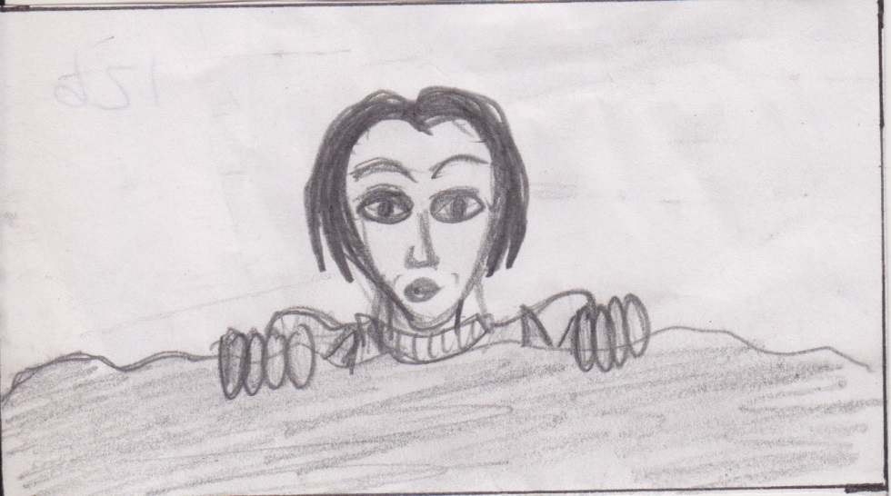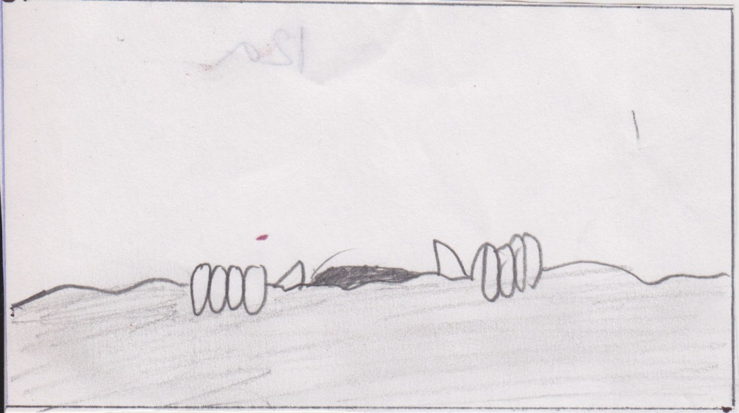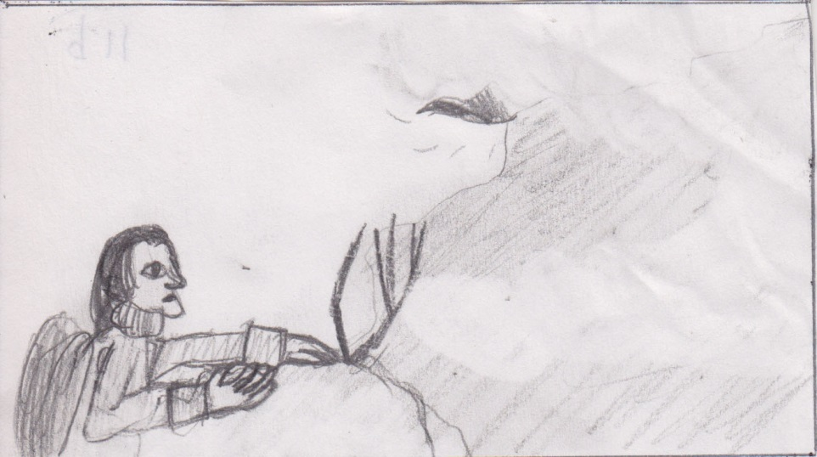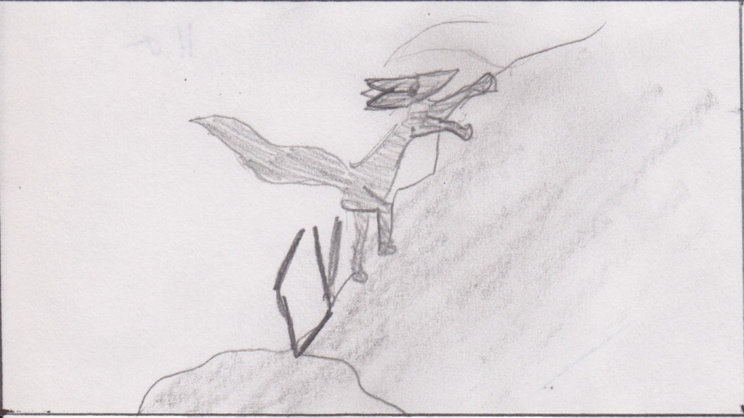

**Shot 12 – 57 frames.**

Close up, man (large version), rock edge set

Man places hands onto rock edge and pulls himself upwards, looking with surprise at what he sees in front of him.

**Shot 11 – 109 frames.**

Wide/medium, man and fox, rock set - side

Fox climbs onto rock, when almost disappearing at the top of the screen (into mist?) man comes into shot at the bottom, starts climbing the rock.

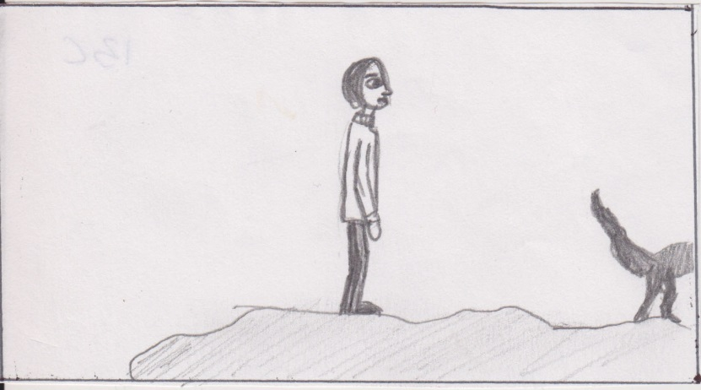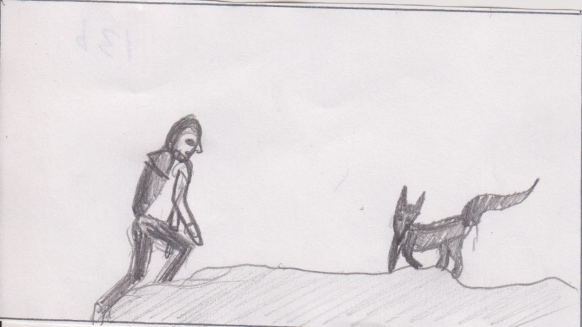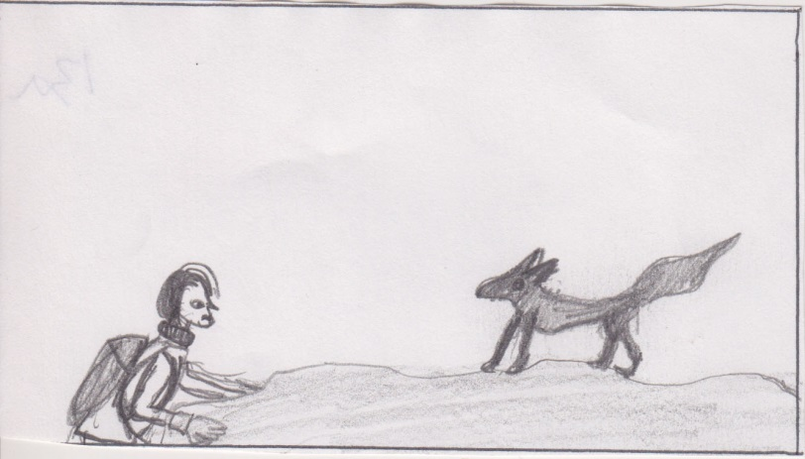

**Shot 13 – 83 frames.**

Wide shot, man (small version) & fox, rock set – side (top part)

Man continues climbing onto rock, fox is standing on rock watching man, stepping backwards when man approaches him. Man stops when fully on top of rock, and looks in front of him.

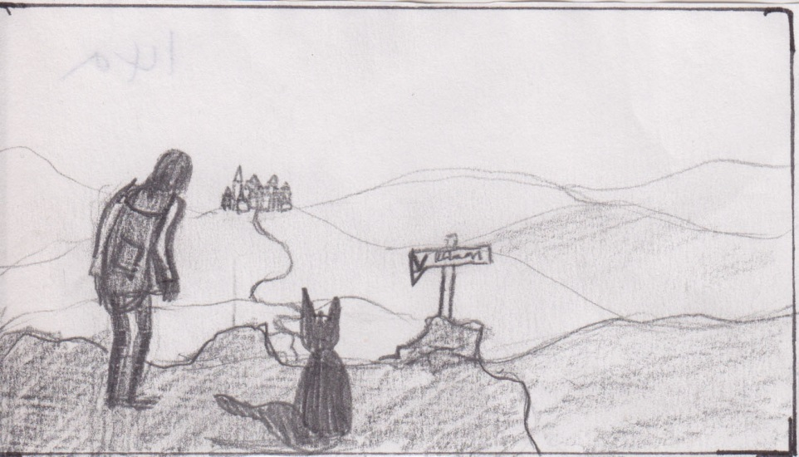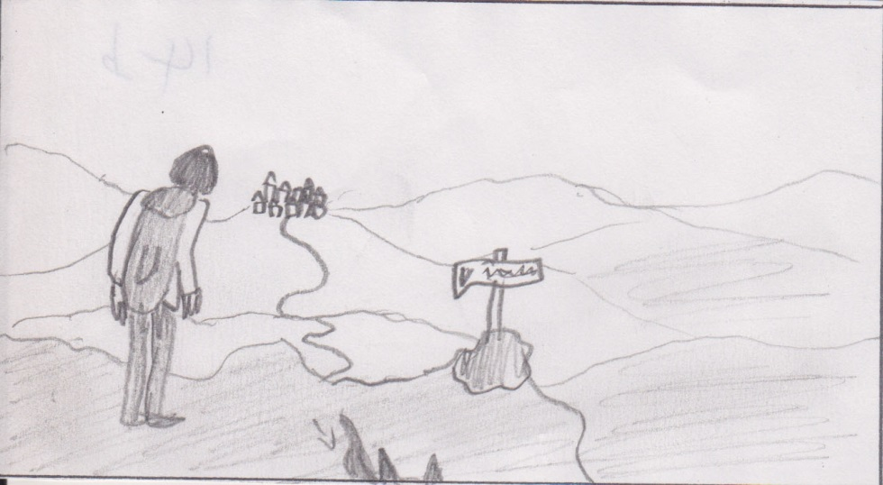

**Shot 14 – 142 frames.**

Wide shot, man (small version) & fox, rock set – top  
 (wide view composited in later)

Man is turning around looking around the wide view and then focuses on view in front of him, looks at sign board, then at town fox sits behind him